C/C++ TIC-TAC-TOE LAB REPORT

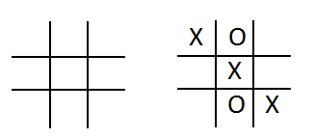
1) Enter your name, student ID, platform (Mac or PC) and date
Name and Student ID: Jay Gupta, Student ID: 0961979
Class: CIS054 C/C++ Programming
Platform (Mac or PC): PC
Date: 3/24/2020

DESCRIPTION
Create a program using a two-dimension array and functions that lets two players play the tic-tac-toe game. The program is to read a number from 1 to 9 from the keyboard alternating between the X and the O. Ask which square the X player wants, and then ask which square the O player wants. Continue until the game is won by either player, or all the squares have been filled. (Called a Cat's Game or a Tie Game)

A function must be used to display the tic-tac-toe game board, and a function must be used that determines if the game has been won. You can create the program on your own, or start with the sample code provided.

EXTRA CREDIT (up to 3 points)
Modify the displayTicTacToe() function using the | and – characters to draw lines for the tic-tac-toe display.

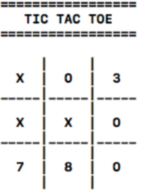
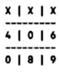
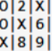
3 points
extra credit
2 points
extra credit
1 point
extra credit

LAB REPORT
2) Determine the Inputs, Processing and Outputs before creating the program
INPUTS | PROCESSING | OUTPUTS
- Numbers 1-9 from each player | - Randomly choose the user’s character.  - Display the board, whilst taking in values, filling the board until there is a winner, or a tie occurs.  - Display the outcome of the game. | - Current Game Board  - Who won, or if it was a tie

DISCUSSION
3) Complete the DISCUSSION section. It does not need to be long, but it needs to be complete.
3a) What did you do to develop the program? ("Followed the Directions" is not a complete description)

First, I thought about what functions would be needed, and consulted the sample code for help and general ideas. I spent a significant amount of time designing the board, and made sure there were no errors with checkForWinningGame, since these were the easiest for me to program. The main function’s while loop posed the most challenge, and I had to understand how the program would work; the sequence of events, and how things like illegal values would be checked. As I will explain below, I ran into a few errors, and checked StackOverflow for answers and help.

3b) What problems did you have and how did you overcome the problems?

I had a few problems creating the board, because I wanted the three extra credit points. It had to do with the vertical pipes and dashes, as it took some time for me to realize that the middle columns were the ones that had to have them on both sides, and the dashes should be added separately. I was trying to create everything in one loop/block, but I realized with my current skill level this wouldn’t be possible. To fix this, I created multiple loops and conditionals, testing as I went along. Testing played a large part in my understanding, and I used it to overcome my problems with the while loop.

4) Show screen shots for at least FOUR sample games: 1) a win going across, 2) a win going down, 3) a win going at a diagonal, 4) a tie game in which there was no winner.

Win going across:
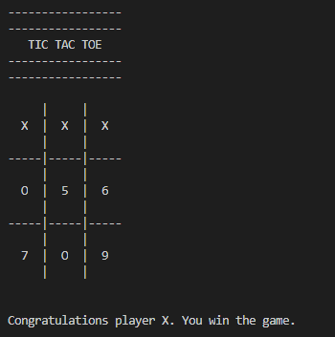

Win going down:
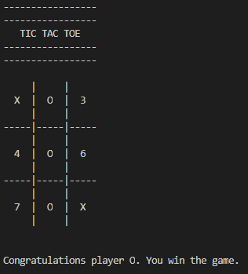

Win going diagonal:
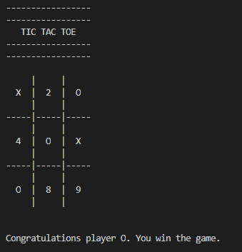

Tie game:
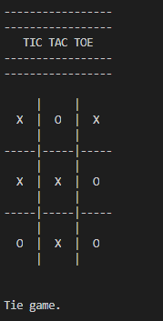

PROGRAM LISTING
5) Copy and paste the code that YOU typed to make the program work. Your program should include a comment block at the top that shows the name of the program, date, version and your name.
// Program Name: tic_tac_toe.cpp
// Name: Jay Gupta
// Class: CIS 054 C/C++ Programming
// Date: 3/24/2020
// Version: 1.0

#include <iostream> // cin and cout
#include <ctime> // time function
using namespace std;

void displayTicTacToe(char board[3][3]);
char checkForWinningGame(char board[3][3]);

int main() {
char board[3][3] = {
{'1', '2', '3'},
{'4', '5', '6'},
{'7', '8', '9'}
};

int squareCounter = 0; // count how many squares are used; to determine a tie
char gameWinner = '-'; // winner of the game ('X', 'O', or none)
char inputCharacter; // input from the user (from '1' to '9')
int choice; // input converted to integer from 0 to 8, as an array starts at 0
char player; // current player, 'X' or 'O'

// select starting player
srand((unsigned int) time(NULL)); // seed random number generator
if (rand() % 2 == 1) {
player = 'X';
} else {
player = 'O';
}

// starting instructions
cout << "Enter a number from 1 to 9 to select a square." << endl;

// ask for 1-9 until all squares are filled, or there is a winner
while (squareCounter < 9 && gameWinner != 'X' && gameWinner != 'O') {
cout << "--------------------------------" << endl;
displayTicTacToe(board);
cout << "Player " << player << ", enter a number (1-9): ";
cin >> inputCharacter;

// convert inputCharacter to integer from 0 to 8
choice = inputCharacter - '1';
int row = choice / 3;
int col = choice % 3;

if (choice < 0 || choice > 8) {
cout << "Illegal value, try again." << endl;
} else if (board[row][col] == 'X' || board[row][col] == 'O') {
cout << "This space has already been used, try again." << endl;
} else {
board[row][col] = player; // put player's character at the specified spot
squareCounter++;

// select the next player
if (player == 'X') {
player = 'O';
} else {
player = 'X';
}
}
gameWinner = checkForWinningGame(board);
}

// someone has won or there has been a tie
displayTicTacToe(board);
cout << endl;
if (gameWinner == 'X' || gameWinner == 'O') {
cout << "Congratulations player " << gameWinner << ". You win the game." << endl << endl;
} else {
cout << "Tie game." << endl << endl;
}

return 0;
}

// displays the current board
void displayTicTacToe(char board[3][3]) {
cout << endl;
cout << "-----------------" << endl;
cout << "-----------------" << endl;
cout << " TIC TAC TOE " << endl;
cout << "-----------------" << endl;
cout << "-----------------" << endl;
cout << endl;

cout << " | | " << endl;
for (int row = 0; row < 3; row++) {
for (int col = 0; col < 3; col++) {
if (col == 1) {
cout << " | " << board[row][col] << " |";
} else {
cout << " " << board[row][col] << " ";
}
}
if (row == 0 || row == 1) {
cout << endl << " | | ";
cout << endl << "-----|-----|-----";
cout << endl << " | | ";
}

cout << endl;
}
cout << " | | " << endl;

cout << endl;
}

// returns 'X' or 'O' for winner
// or '-' for no winner
char checkForWinningGame(char board[3][3]) {
char player;

// across top row
player = board[0][0];
if (board[0][1] == player && board[0][2] == player) {
return player;
}

// across middle row
player = board[1][0];
if (board[1][1] == player && board[1][2] == player) {
return player;
}

// across bottom row
player = board[2][0];
if (board[2][1] == player && board[2][2] == player) {
return player;
}

// down first column
player = board[0][0];
if (board[1][0] == player && board[2][0] == player) {
return player;
}

// down second column
player = board[0][1];
if (board[1][1] == player && board[2][1] == player) {
return player;
}

// down third column
player = board[0][2];
if (board[1][2] == player && board[2][2] == player) {
return player;
}

// left diagonal (\)
player = board[0][0];
if (board[1][1] == player && board[2][2] == player) {
return player;
}

// right diagonal (/)
player = board[0][2];
if (board[1][1] == player && board[2][0] == player) {
return player;
}

// if there's no winner
return '-';
}

